Homework 1 Individual Assignment

Name: Student ID:

NOTE: This assignment and the respective submission is subject to the plagiarism rules all students are responsible for which is outlined in the course syllabus available through the course resources on Canvas.

# (10 points) Lab Safety Questions: Circle the correct answer where “T” for “True” & “F” for “False”.

* 1. I can dispose chemical & oil waste in sink because I do not see any posted warnings on chemical disposal & safety. T F
  2. I should not store strong acid & organic containers in the same compartment to prevent hazard.

T F

* 1. In case of lab emergency I will call my parents for help instead contacting the phones provided by the lab instructor. T F
  2. In case of a fire that I am unable to contain with fire extinguisher, then I shall run away from that area, warn all others and help them evacuate safely and seek immediate help by calling the fire department.

T F

* 1. I can horseplay, and make loud noises in the lab if I finish my experiment ahead of others

T F

* 1. If I am impaired due to sickness and taking medications that causes drowsiness then I should avoid operating any machinery T F
  2. I can clean the machine components when the machine button is off and no need to disconnect its power line. T F
  3. Always use eye protection safety goggles and face shield when working on my lab or operating any machinery T F
  4. Sandals and flip flop and loose garments are allowed during lab work or when operating machinery

T F

* 1. I can work alone when operating machinery or during energizing electrical equipment T F
  2. I can wear my suit and a tie, and have my long hair loose when inspecting or operating motors T F

# Sketch your P2 idea in 3D using an exploded view.

An exploded view is a technical drawing that shows the relationship and order of the assembly of various components of an engineering object. Each component of the object is displaced an equal distance from the other components. Each component is indicated by a line or arrow and labeled. For complex engineering objects with many components, each component is assigned a number. A part list then provides the numbered label and the corresponding name of the component. The exploded view assists in assembly of the object. The exploded view is a typical diagram in manuals and patent applications. An example of an exploded view is provided in the example

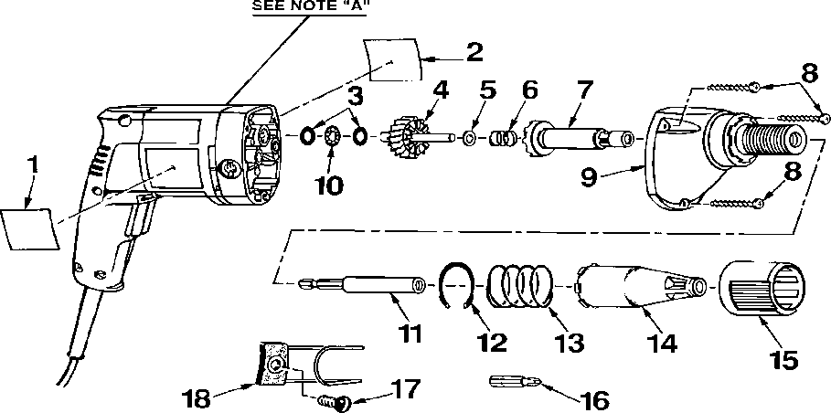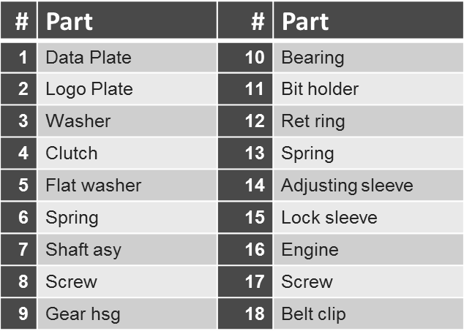of Sear’s powered screwdriver as shown in Figure 1. Either hand sketches or computer aided design drawings are acceptable in your exploded view of your idea of P2 project.

Figure 1: Exploded View of Corded Screw Driver with Parts List [https://www.searspartsdirect.com/model/ma617rbw9v-000247/craftsman-315271450-power-](https://www.searspartsdirect.com/model/ma617rbw9v-000247/craftsman-315271450-power-screwdriver-parts) [screwdriver-parts](https://www.searspartsdirect.com/model/ma617rbw9v-000247/craftsman-315271450-power-screwdriver-parts)

1. Select the correct answer for the following questions:
2. A measurement that closely agrees with accepted values is said to be .

|  |  |
| --- | --- |
|  | Accurate |
|  | Precise |
|  | Reliable |
|  | Significant |

1. Which experiment is precise?

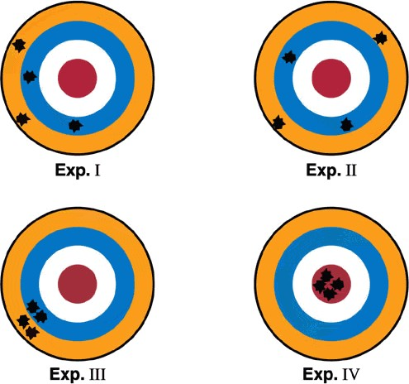

|  |  |
| --- | --- |
|  | Experiment 1 |
|  | Experiment 2 |
|  | Experiment 3 |
|  | Experiment 4 |

1. The accuracy of a measurement

|  |
| --- |
| is how close it is to the true value. |
| does not depend on the instrument being used to measure the object. |
| indicates that the measurement is also precise. |
| is something that scientists rarely achieve. |

1. A student determines measures the mass of one mole of carbon and finds it to be 12.22 grams. If the accepted value is 12.11 grams, what is the students % of error.

|  |
| --- |
| 0.0091% |
| 0.091% |
| 0.91% |
| 9.1% |



1. A chemist who frequency carries out the same complex experiment is likely to have high

 .

|  |
| --- |
| accuracy |
| precision |

1. The difference between statistical error and systematic error is best described by which of the following?

|  |  |  |
| --- | --- | --- |
|  | (a) Statistical error is due to an introduced bias, while systematic error is d random fluctuations. | ue to |
|  | (b) Statistical error is due to random fluctuations, while systematic error is an introduced bias. | due to |
|  | (c) Statistical error can be eliminated, while systematic error cannot. |  |
| (d) Statistical error is due to statistics, while systematic error is due to the system. | |  |

1. When scientists report error in their data, they are:

|  |  |  |
| --- | --- | --- |
|  | (a) presenting the probability that their research will turn out to be wrong | . |
|  | (b) admitting that their research is wrong. |  |
|  | (c) detailing the mistakes that they have made. |  |
| (d) quantifying the variability associated with their measurements. | |  |

1. The number 0.00442 would be written in scientific notation as:

 0.442 x 10-2  4.42 x 10-3  442 x 105

 4.42 x 103

1. How many significant figures are there in the number 0.060?

1

 2

 3

 4

1. How many significant figures are there in the number 6,130?

1

 2

 3

 4

1. Questions on random and systematic error.
2. What is the difference between random and systematic errors?
3. Provide 2 examples of random errors.
4. Provide 2 examples of systematic errors.

5. H(cm)=183,161,176,173,181,172,186,173,160,189,179,181,168,183,153,186,175,

159,163,177 Decide a reasonable bin range, and plot a histogram by hand. Solve for the mean, median, and mode of the student heights in centimeters. Label your height in this figure.

6. Use the following bin information:

|  |  |  |  |  |  |  |  |  |  |  |
| --- | --- | --- | --- | --- | --- | --- | --- | --- | --- | --- |
| Bins | 0-  60 | 60-  65 | 65-  70 | 70-  75 | 75-  80 | 80-  85 | 85-  90 | 90-  95 | 95-  100 | 100+ |
| Letter | F | D | C- | C- | B- | B- | B+ | A | A+ | A+ |

Overall Class Grades: 68, 68, 77, 58, 64, 72, 87, 78, 72, 83, 73, 78, 76, 88, 80, 87, 69,

99, 94, 84, 99, 91, 91, 83, 81, 93, 102, 96, 90, 81, 31, 82, 85, 90, 88, 93, 83, 97, 74, 70,

70, 77, 88, 84, 84, 70, 97, 93, 98, 92, 82, 97, 67, 85, 101, 77, 86, 84, 92, 54, 84, 85, 65,

82, 52, 91, 63, 85, 65, 93, 69, 98, 88, 92, 72, 91, 77, 73, 80, 73, 75, 55, 67, 82, 98, 93,

92, 77, 100, 89, 76, 83, 59, 83, 94, 96, 93

Calculate the (1) Mean, (2) Median and (3) Standard Deviation of the overall class grades using only your calculator. Next, (4) create a histogram in excel. Label the

(5) mean, (6) median and (7) standard deviation in the figure. Include all your findings with calculations in your Homework 1.

∑𝑛(𝑥̅−𝑥𝑖)2

Recall the Standard Deviation: = √

1

𝑛−1

, 𝑥̅ = 𝑚𝑒𝑎𝑛, 𝑛 = # 𝑜𝑓 𝑠𝑎𝑚𝑝𝑙𝑒𝑠